CHECKLIST FOR ILRN 2026 CAMERA-READY PAPERS (Extended Abstracts, DC, iLEAD)

Submission ID: Enter submission ID here
Submission type: Extended Abstracts Doctoral colloquium paper / iLEAD contribution [Delete as appropriate]
Title: Enter paper or extended abstract title here (As it is in the final version, e.g.: Extended Abstracts—A Mobile Augmented Reality App for Teaching Geometry)
Please confirm that your final submission satisfies each of the requirements below. Failure to meet any of these requirements may result in your paper being excluded from the proceedings.
Please add your name next to each requirement in the list to mark it as completed | Requirement
 | - The Program Chairs’ and reviewers’ feedback has been thoroughly addressed, with appropriate revisions made to the paper or extended abstract considering their feedback. A table of responses to their comments has been prepared (see the “Responses to Program Chairs’ and Reviewers’ Comments” table at the end of this document).
- iLRN’s Proceedings template has been used to prepare the paper.
- I used the template as it is, and I didn’t change the paper size or margins.
For MS-Word: All instructions and examples in the template have been strictly adhered to, and the final output compared side-by-side with a fresh copy of the template to ensure all elements appear exactly as they should.
- All template text that is not part of the paper or extended abstract have been removed.
- Formatting of the paper or extended abstract has been done using the predefined MS-Word styles in the template, rather than manually.
- Any email addresses and URLs within the file are not rendered as hyperlinks (i.e., they must not be blue and underlined).
- Referencing and citations are in full compliance with Springer’s MathPhySci format, with particular attention paid to which elements of a reference are in Title Case vs Sentence case, which are italicized, which are enclosed in quotation marks, where commas and full stops are used, etc. When citing multiple references at once in the text, all cited references are in square brackets and separated by a comma and space (e.g., [1, 3]), and when citing more than two consecutive references, they are represented as a range with an en dash (-) in between the first and last reference (e.g., [4–7], note there are no spaces on either side of the en dash).

Examples:
• Single citation: [9]
• Multiple citation: [4-6, 9]. The numbers should be listed in numerical order.
• If an author’s name is used in the text: Miller [9] was the first …

- The paper or extended abstract is within the page limits for the contribution type:
- Short Papers: 8 - 11 pp
- Extended abstracts and Doctoral Colloquium papers: 4 - 7 pp.
- iLEAD: 2 to 5 5 pp.
No blank pages at the end of document.
- Page setup:
Paper size is set to A4 size.
Portrait orientation.
Margins are set to Top = 2.54 cm / 1.0 in, Bottom = 2.54 cm / 1.0 in, Left = 2.54 cm / 1.0 in, Right = 2.54 cm / 1.0 in.
 | - The title of the paper or extended abstract is in Title Case. (Use the tool at https://titlecaseconverter.com/ to ensure the title is in the correct case; select “Chicago” as the style.) The title must not contain any line breaks. If there is a subtitle, it should be placed on the same line as the title, following a colon, in the same font size. The title must not be bolded, italicized, underlined, etc. There should be no full stop at the end of the title, and it must not be in quotation marks. The title must be prefixed with the type of contribution (i.e., Work-in-Progress, Workshop, Special Session, Panel Session), followed by an em dash (—). For example: Work-in-Progress—A Mobile Augmented Reality App for Teaching Geometry (Note there should be no spaces before or after the em dash.)
- Author names, affiliations, email addresses, references to the authors’ own publications, acknowledgments and other identifying information previously removed to facilitate blind review have been reinstated in the paper.
(DO NOT number authors to indicate the authorship order. The order is reflected in the submission metadata.)
Double-check that all the authors are included, correctly spelled and in the correct order. After the camera-ready documents are submitted to the publisher it will not be possible to change any of these details.
 | - Abstract is prefixed with the string Abstract in bold, then a full stop (.), then the text of the abstract. The abstract text itself should not be in bold or italicized, and should not contain symbols, special characters, or math. Abstract must be a single, continuous paragraph (no manual line/paragraph breaks) and must not be longer than 250 words. The contribution type must be mentioned somewhere in the abstract (e.g., “This work-in-progress paper describes …” or “In this workshop, …”).
 | - Keywords are prefixed with the string Keywords in bold, then a colon (:), then the actual keywords. All keywords in Title Case and separated by commas (,), not semicolons (;). Full stop after the last keyword.
- Section headings are in Title Case.
Examples:
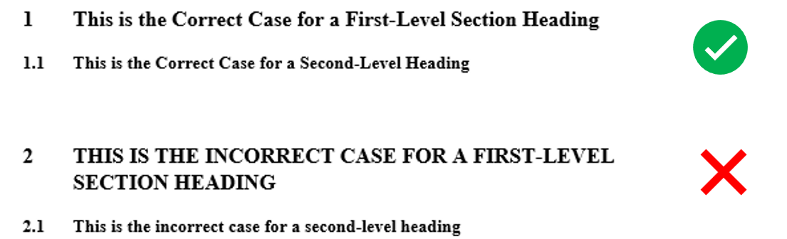

 | - The first paragraph of a section or subsection is not indented. The first paragraphs that follows a table, figure, equation etc. does not have an indent, either. Subsequent paragraphs, however, are indented.
- Table styles are as per the template. Table captions appear above tables, not below. Table column headings are in Sentence Case. Tables are numbered using Arabic numbers (1,2,3, etc.), and referred to in the main text as such. Examples:
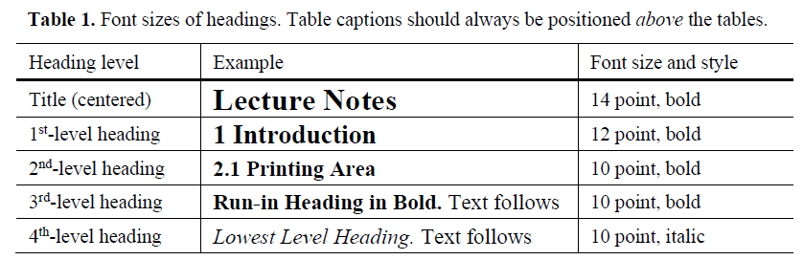

- Figure captions are below the figure, not above. They are preceded with “Fig. X” (where X is the Arabic number of the figure 1, 2, 3, etc.), not “Figure X”. Any references to figures in the main text should also be in this form.

Captions are set in 9-point type. If they are short, they are centered between the margins. Longer captions, covering more than one line, are justified.
Tables and equations should not be pasted in as figures, as they may need to be edited for formatting reason.
- Acknowledgments:
This should always be a run-in heading and not a section or sub-section heading. It should not be assigned a number. The acknowledgments may include references to grants or support received in relation to the work presented in the paper. Authors should make sure that they have included all necessary acknowledgments before sending the files. Updates at a later stage are not possible.

RESPONSES TO PROGRAM CHAIRS’ AND REVIEWERS’ COMMENTS

Please use the table below to record your responses to each of the issues raised by the Program Chairs’ and reviewers in their comments, briefly describing the action/s you have taken when revising your paper considering their feedback (e.g., what additions or changes you made). Additional rows may be added to the table as necessary.

Reviewer No.  (enter “PC” for Program Chairs) | PC Chair or Reviewer Comments | Author Response and Action(s) Taken

